Apprentice Name:
Apprenticeship Start Date:
Date of successful Completion (optional):
Name of Sponsor/Mentor/ Nominator:

Trust/Co Name:

Position /Title:

Contact Number/Email:

Nominator: Please complete appraisal questions below (5 marks per question):
Please briefly explain the reasons for making this nomination. (Maximum 100 words per question)

Questions: | Score = of 5
Provide a short overview covering a description of the qualification they were enrolled in, the registered training organisation - and the reason for choosing this training pathway. (max 100 words)  Answer: | Not Scored
- What was their motivation in choosing an apprenticeship educational route?
Answer:

- Describe with evidence, how the nominee has effectively collaborated with other team members or departments
Answer:

- Can you describe where the nominees went above and beyond their expected duties
Answer:

- How does the nominee engage with their mentor / supervisor / manager?
Answer:

- How has the nominee shown initiative and or excellence in the application of their knowledge?
Answer:

- Describe any significant achievements which demonstrates exemplary application of knowledge and leadership skills and behaviour in the course of completing or doing your apprenticeship.
Answer:

- What personal goals have been achieved during the course
Answer:

Matrix for Scoring:
0 | Does not meet criteria
1 | Poor Response
2 | Acceptable response
3 | Meets Criteria
4 | Provides great detail
5 | Exceeds required detail

Supporting Attachments / additional comments (Maximum of 5 single-page attachments).
The award panel will appraise the skills of the nominee (based on the answers to the appraisal questions); however, additional relevant evidence may be provided to support the nominee. Any supporting attachments must be referenced within the appraisal questions.

This may include:
- Evidence of competent knowledge application in the workplace (Evidence must be submitted at the time of application) Examples:
  - Certificate of Proficiency.
  - Signed (mentor/manager) Competency-based completion table.
- Awards and prizes: Copies of any certificates or prizes they may have received.
  - such as special recognition by your employer.
- Short Nominee Resume / CV.
- Reference or letter of support: A reference or letter of support from either your employer/host employer, trainer, or teacher.
- Workplace/training action photos: Action photos of you in your workplace or training.
- Feedback or testimonials from colleagues, supervisors, patients etc

Programme:

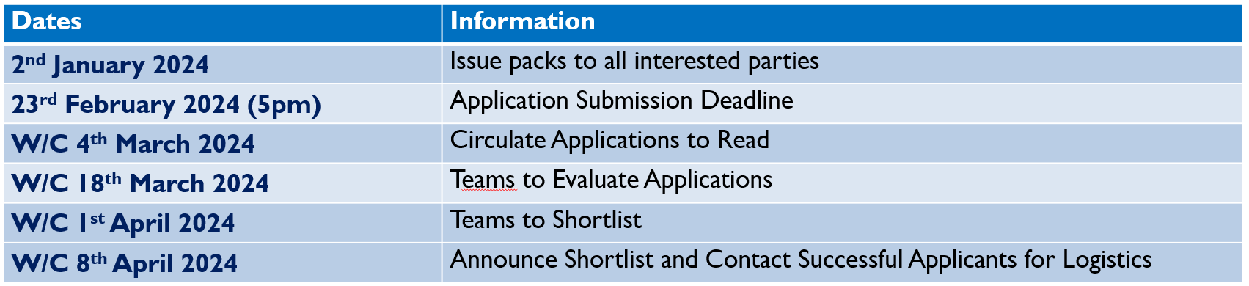

Return this document by 23rd February 2024, 5pm, to:

Nicola Parkes – Awards Administrator
MTS Health
61 Maxted Road
Hemel Hempstead
HP2 7DZ

Telephone 01442 216785
Email nicola.parkes@mtshealth.co.uk

